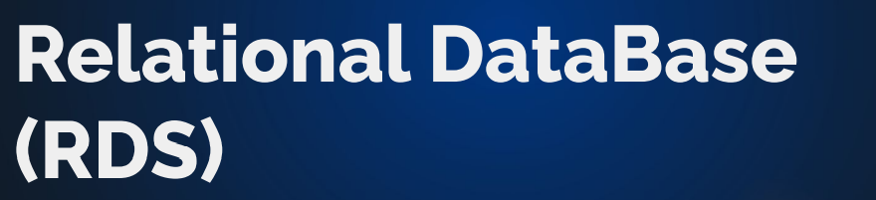

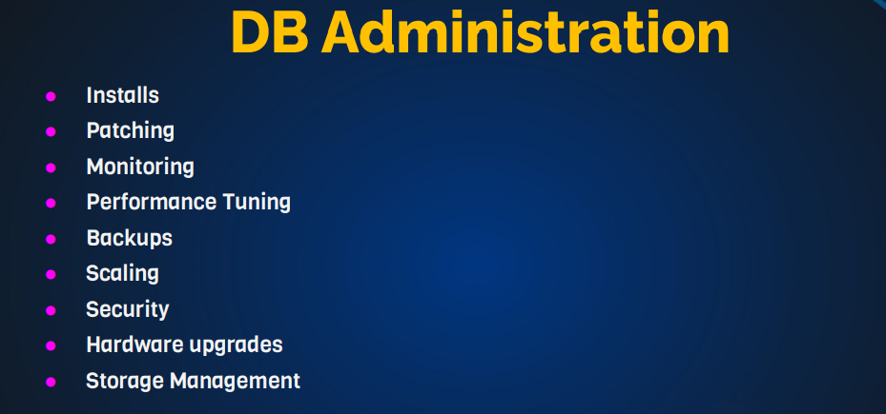

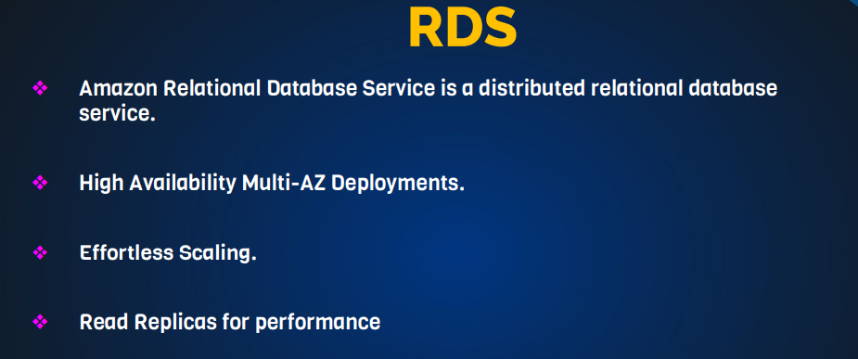

AMAZON RDS:

It is a database service from Amazon Aurora. It supports serverless and 64TB of auto-scaling storage

Amazon Aurora is like and better than mysql and postgreSQL. It is faster and has more storage than mysql.

STEPS:

* login to your amazon console and search for RDS under services
* click create database and go for the easy create
* Select your engine option, for these explanation; MySQL was selected
* version ….. MySQl 5.7.22 according to my requirement
* pick your template…. Dev/Test is used here
* under settings: give a name (E.g: vprofile-mysql-rds), port no: 3306, monitoring role: Default
* click create and get the endpoint url to access the database (If the public access is set to NO!, then the endpoint wouldn’t work).
* create an EC2 instance in the same region to access if the public access is no. Choose Ubuntu
* Name the instance MySQL-client, use same keypair and but different security group, once created SSH to it. Go to git bash
* make sure you have the following details of the RDS: Endpoint, Username & Password you used when setting up.
* sudo –i ……. apt update ….. apt install mysql-client –y
* mysql –h (Endpoint) –u (username) –p(password)
* if it doesn’t connect, press control + c ….. cancel
* check connection: telnet (Endpoint 3306) ….. remember 3306 is the port no
* if it doesn’t connection check the security group of the RDS. It should look like (MYSQL/AURORA TCP 3306 CUSTOM -- Allowed from the SECURITY GROUP OF THE INSTANCE)

(MYSQL/AURORA TCP 3306 CUSTOM -- Allowed from the PRIVATE IP OF THE INSTANCE)

* Now you should be able to Login: mysql –h (Endpoint) –u (username) –p(password)
* perform the normal database commands
* Go back to your AWS and make sure you always perform snapshots as you work